**Canurta NFTs: The Healing Project Whitepaper** Presented by: Canurta Inc.

January 2022

**Table of Contents**

About Canurta

Problem Statement

Introducing The Healing Project

Why Now?

How it Works

Unique Community Benefits to $THP Token Holders

Platform Details

Advanced Manufacturing Supply Chain

Environmental, Social and Governance

Funding Allocation

Creative Director

Research Team

Key Partnerships

Conclusion

Appendix 1: IP Summary

Appendix 2: What are NFTs?

Appendix 3: Canurta Team

**About Canurta**

Canurta designs all-natural and innovative ingredients from hemp polyphenols to effectively support inflammation prevention and recovery. Our product innovation is accelerated by blockchain solutions and community-driven research.

Canurta’s mission is to solve the world’s biggest health challenge: preventing and managing chronic disease safely. We target inflammation because it is the root cause of disease. And we build natural solutions backed by science to rival synthetic anti-inflammatory ingredients that aren’t safe for daily or long-term support.

Apart from cannabinoids like CBD, the hemp plant contains over 400 bioactive compounds, including unique cannflavin-rich polyphenols that only Canurta can identify, optimize and capture. Cannflavins A and B are valuable due to their ability to eliminate inflammation at the source through dual inhibition of pro-inflammatory pathways.

Canurta connects proprietary technology with a leading network of researchers through a Decentralized Science or “DeSci” model to overcome the challenges of bringing rare, inflammation-fighting hemp polyphenols to market. We incentivize the development of safer, and more effective natural solutions while allowing communities of donors, scientists and patients to work together on clinical design and impactful healthcare discovery.

Canurta will launch its products in 2022, which will benefit from deeper investigation and an expanded supply chain through the sale of The Healing Project NFT.

**Problem Statement**

Chronic inflammation presents some of the most pervasive health challenges facing the world today. Ischemic heart disease, stroke, cancer, diabetes, arthritis, fatty liver disease and both auto-immune and neurodegenerative conditions are only a few examples of common illnesses linked to inflammation. Worldwide, 3 of 5 people die due to chronic inflammatory diseases like stroke, chronic respiratory diseases, heart disorders, cancer, obesity, and diabetes (1).

Conventional treatments do not eliminate the source of inflammation and can be responsible for other ailments during or after treatment. These treatments typically involve the administration of nonsteroidal anti-inflammatory drugs (NSAIDs), opioids, glucocorticoids and immunosuppressant drugs, which are not ideal for everyone, can trigger addictions and include a range of side effects.

Advancements in research and development are pivotal in addressing the increasing interest and urgent need for natural, alternative treatments to alleviate inflammation related diseases. Healthcare research, however, has often grappled with the challenges of acquiring adequate funding which is usually subsidized in two ways: through government funds and private investments.

While the former requires extensive time and resources coupled with high-failure rates and competition rather than collaboration, the latter is often cited as being a means of bias and personal gain. Combined, these barriers have compromised progress towards a real solution.

With botanicals growing in popularity as an inflammation treatment, non-fungible tokens (NFTs) are also being embraced as a new method of democratically funding critical healthcare research and development. By pairing NFTs and healthcare research, there is an exciting opportunity to explore novel, promising alternatives in a modern, culturally relevant way that eliminates accessibility obstacles while remaining autonomous, transparent and accountable.

**Introducing The Healing Project**

Canurta presents The Healing Project, a collection of Utility NFTs that leverage IP and blockchain solutions to advance the development of safe and natural solutions for chronic disease.

DeSci, or Decentralized Science, is the future of health discovery, allowing a diverse array of stakeholders to participate in clinical design, democratize product development and accelerate the build of a blockchain-enabled biotech organization.

The Healing Project will launch with five fractionalized NFTs, making up a total of 10,000 ($THP) utility tokens on Ethereum blockchain.

Proceeds from the sale will not only advance research, but also facilitate the first-time commercialization of novel, patented (*see Appendix 1*), hemp polyphenols, including Cannflavins A and B. These rare polyphenols are scientifically proven to be powerful anti-inflammatory molecules that have potential to rival synthetic anti-inflammatories shown to carry dangerous risk profiles that an overwhelming number of patients prefer not to take long-term.

This will improve treatment options (2) for those affected by chronic disease(s) and accelerate new research methodologies and innovation in botanical drug development.

The Healing Project incentivizes collective action by connecting in real life (IRL) revenue-to-donation opportunities that will fund and guide charitable donations. The Healing Project token holders willhave the ability to vote on the annual cause-of-choice donation for 1% of revenue generated from the sale of products With Canurta. In collaboration with emerging local artists, The Healing Project will continue to develop creative works and collections over the years with new sets of collectible NFT artworks and experiences.

The use of blockchain technology to host the project will permit transparent monitoring of project outcomes thereby serving as a measure and immutable record of the Package Owner's contributions.

To learn more about NFTs, please see Appendix 2.

**Why Now?**

Accelerate fundraising and build of community-driven health systems

Provides a new, DeSci, business model for research and development rooted in transparency and improved methodologies

Ground breaking opportunity to solve chronic inflammation and inflammatory related diseases with novel, safe polyphenols

Improved interactions between researchers, patient communities and analysis of research outcomes

**How it Works**

The Healing Project Package will contain five fractionalized NFTs. The Community will own a total of 10,000 fractional pieces in the form of The Healing Project ($THP) tokens. Each fraction will be a utility and access token that will allow token holders benefits of the project.

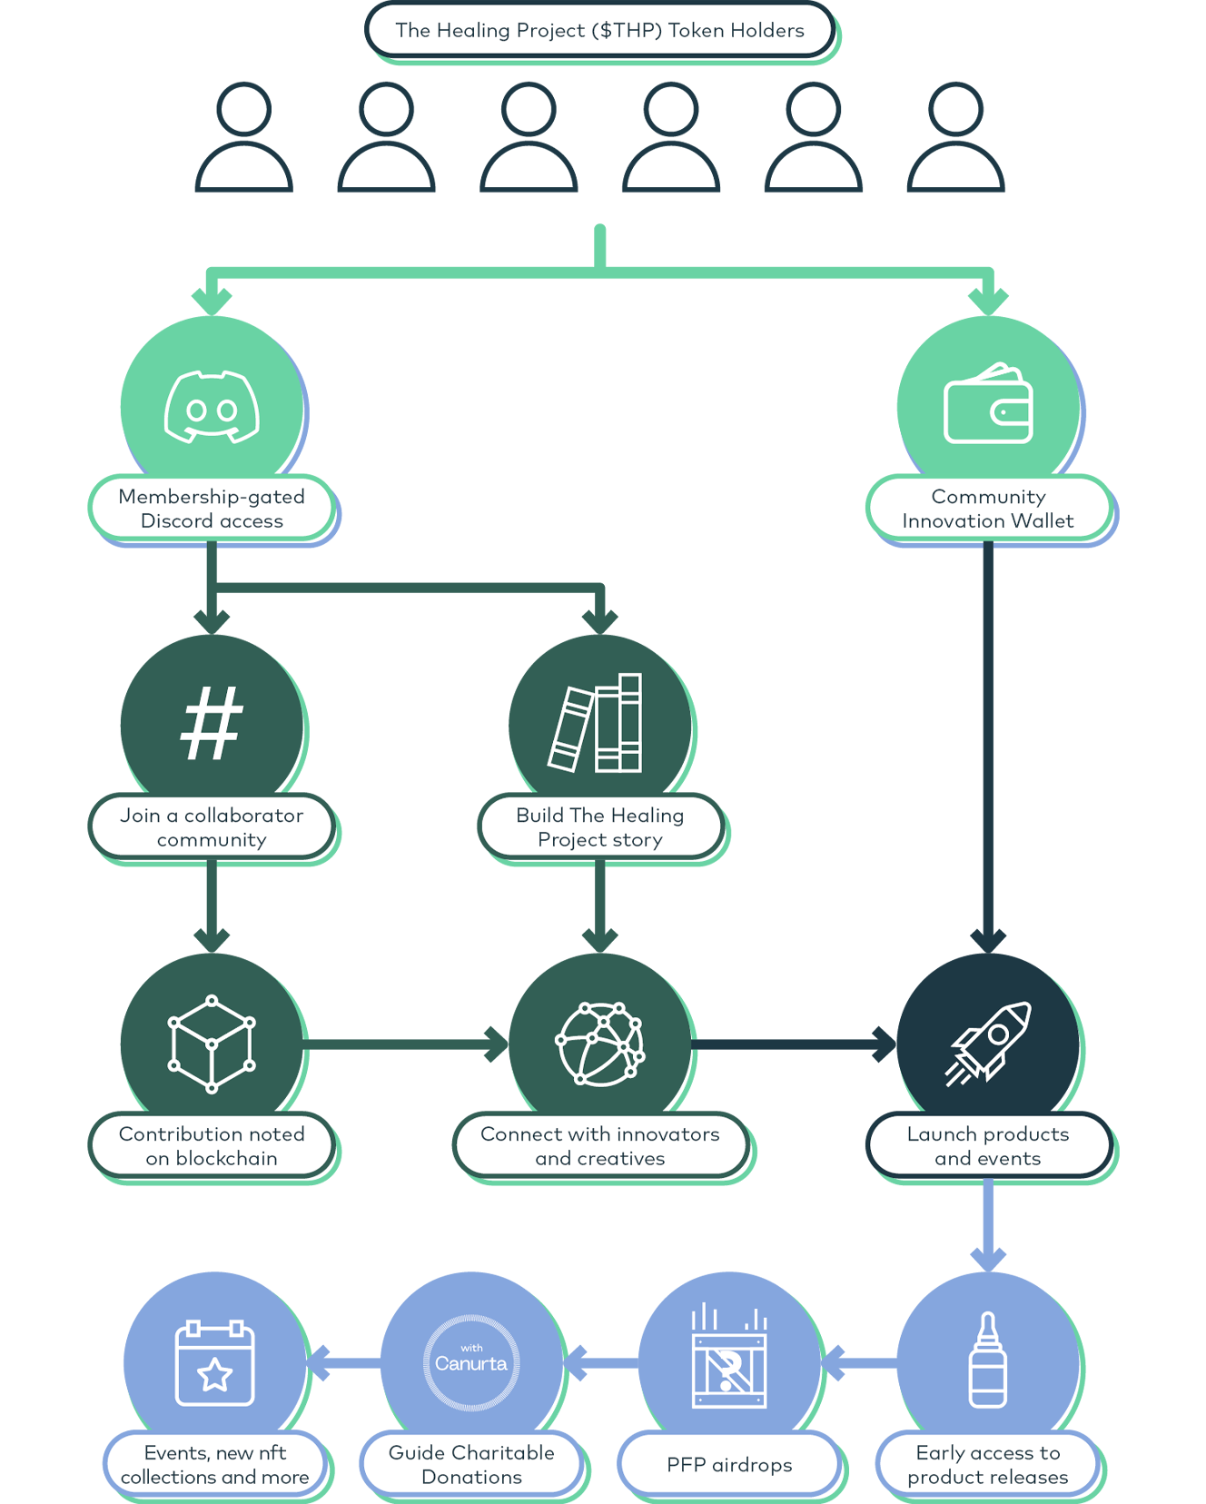

**Unique Community Benefits to $THP Token Holders**

The $THP community will tackle the isolating experience of chronic pain and disease in a fun and community-centric way. Calling on a diverse group of stakeholders, The Healing Project intends to catalyze people all around the world to come together on a mission to Heal the World.

$THP token holders will benefit from:

**Collaborator Communities With Canurta**

Support hackathons and project sprints that will help equalize health care innovation across diverse communities.

**Community Innovation Wallet**

Help build blockchain based supply chains for rare botanical ingredients and their therapeutic discovery.

**Continue to Build The Healing Project Story**

Team Canurta have returned to earth transformed, with rare, powerful gifts from the giant spirits. How will they save their fellow humans and animals?

**New Product Perks & Experiences**

Early access to the products you help develop, while we build a new, positive manifesto for community-driven health discovery.

**Guide Charitable Donations**

Vote on the annual cause-of-choice donation for 1% of revenue generated from the sale of products With Canurta.

**Platform Details**

The Healing Project platform is built on various blockchain-related technologies. The NFTs are hosted on Rarible and in the future will be connected to Canurta’s *Blockchain for Canurta Supply Chain* private permission blockchain through the Ethereum blockchain, allowing for the recording of a complete history of data.

Rarible is an Ethereum based blockchain solution service that allows us to curate multiple NTFs with a variety of purposes. Fractional.art was used to fractionalize the five NFTs into 10,000 utility tokens.

Canurta will use a custom built private blockchain built using Hyperledger Iroha to manage the supply chain. Together with Ethereum’s blockchain technology, they create a historian for chained data to foster trust and integrity for its network participants and the general public.

**Advanced Manufacturing Supply Chain**

From sourcing biomass to ingredient formulation, research & development, manufacturing practices and the *revenue-to-donation* outcomes that follow, Canurta commits to social, environmental and economic responsibility with a reliable and trusted supply chain and the following features:

**• Immutability:** Past records of transaction details (Canurta assets being earned, purchased, or created) cannot be changed or altered on the shared ledger.

**• Consensus:** A decentralized approach provides the community with an equal vote in the validity of transactions across the network. Hyperledger Iroha uses Yet Another Consensus (YAC) following principles of ‘Byzantine Fault Tolerance’.

**• Provenance:** Provides consumers with a complete history of data in order to maintain consistency throughout the Iroha network. Hyperledger Iroha has a built-in component called the Synchronizer to ensure all peers in the network are replicas. It implements the Synchronizer through its YAC ordering protocol.

**• Transparency:** Every transaction that has occurred on Hyperledger Iroha will be added to a replica permissioned ledger making it completely transparent and available for the network members to query and make transactions. This significantly reduces the chances of fraud. By leveraging Iroha’s innate permissioned protocols, transactions and queries are made by users with appropriate access through public and private keys associated with their accounts. In addition, keys allow for user accounts to remain confidential to others in the network.

A technical flow of the Blockchain for Canurta Supply Chain can be found in **Appendix 3**.

**Environmental, Social and Governance**

Canurta is firmly anchored in our values including our commitment to ESG principles as guided by our Sustainability Policy. These principles will be intrinsic to The Healing Project.

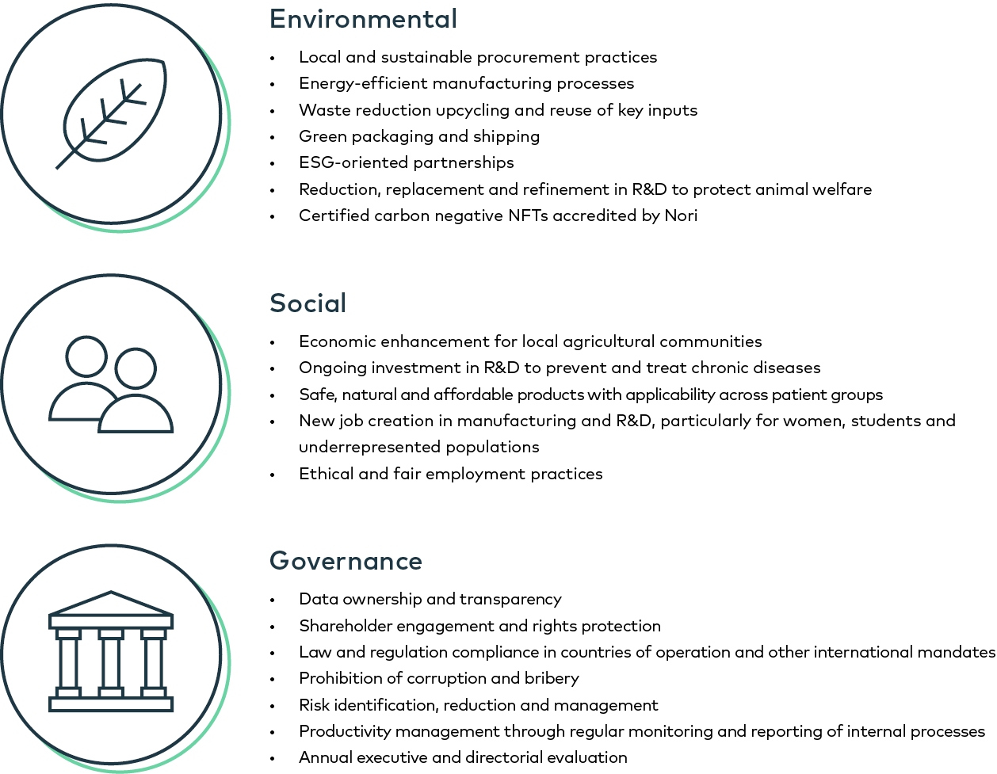

**Funding Allocation**

Funds acquired through the sale of NFTs will be allocated as follow

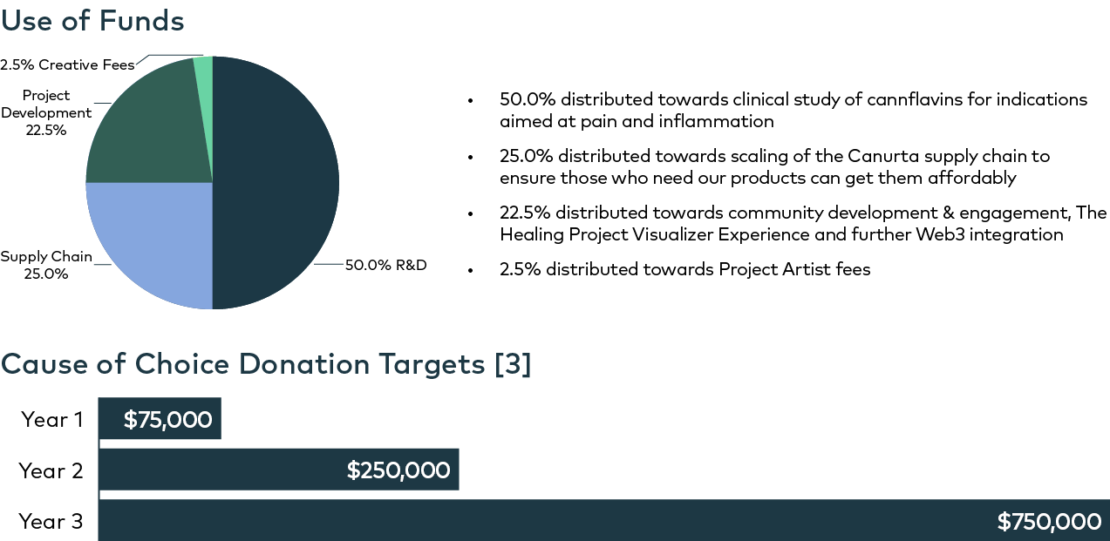

**NFT Creative Director**

Jordan Sook is a mixed media contemporary artist from Toronto, Ontario. His art is inspired by acts of imposition and alteration, recontextualizing elements within pop culture to create new narratives. Jordan looks to change the landscape of Canadian art and broaden the framework and understanding of Black art as a whole.

Jordan’s work ranges from acrylic paintings to sculptures and installations. His work invites us to view the world from a subjective innocence while exploring the relationship to the modern human complex relating to consumerism, economics and the social environment.

Jordan collaborated on The Healing Project artwork with VALMITR, a digital-driven, worldwide design studio that specializes in motion graphics and NFT collections creation.

. 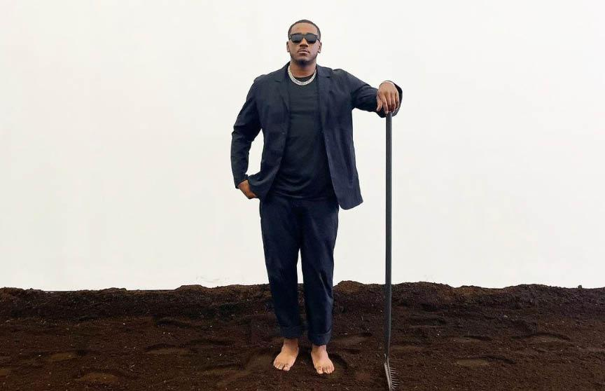

Learn more about Jordan Sook

**Research Team**

**Tariq Akhtar, Ph.D., Principal Investigator** - Dr. Akhtar is a world-renowned plant biologist and has renowned expertise on polyphenolic molecules and their synthesis in the Cannabis Sativa plant. Dr. Akhtar is one of the inventors of Canurta’s extraction and biosynthesis platform patent. The biosynthesis platform produces novel and rare polyphenols with potent, natural therapeutic properties. Dr. Akhtar has ample expertise in plant biochemistry and metabolic engineering. His research focuses on better understanding plant specialized metabolism of compounds that are of economic relevance. He also works closely with collaborators in various fields such as organic chemistry, food science, neurobiology, and ecology, with the overall goal to shed light on the processes that operate at the interface of plant primary and secondary metabolism.

**Dr. Neal Davies, Ph.D., Principal Investigator** - Dr. Neal M. Davies directs the analytical method development and identification and characterization of major components found in our products while developing analytical methodology and validation of assays for cannflavins. He also leads the preclinical discovery of the therapeutic potential of our active ingredients for initial biopharmaceutical classification. Dr. Davies received his undergraduate degree in Pharmacy from the University of Alberta in 1991. In 1996, he completed his Ph.D. in pharmaceutical sciences, specializing in pharmacokinetics, at the University of Alberta.

Throughout his career, Dr. Davies has strived to maintain the highest standard of teaching and research, and his achievements in both areas have been recognized through numerous awards and honours including several from the United States Pharmacopeia and the Canadian Society of Pharmaceutical Sciences. He is active in numerous professional organizations/associations, including the Canadian Society of Pharmaceutical Sciences and the American Association of Pharmaceutical Scientists, and serves as a reviewer and on the editorial board of several pharmaceutical and pharmacological science journals.

**Dr. Ethan Russo, M.D., Senior Medical Advisor** - Dr.Ethan Russo advises and provides essential formulation expertise to the company’s natural product and drug development pipelines. Dr. Russo is a former president of the International Cannabinoid Research Society as well as a past chairman of the International Association for Cannabinoid Medicines. Dr. Russo is also a board-certified neurologist, a psychopharmacology researcher, and author of 50+ peer-reviewed journal articles and 7 books. Moreover, he is a preeminent global medical cannabis expert with over 24 years of clinical cannabis research experience, including his outstanding work at GW Pharmaceuticals as a study physician and medical monitor for Sativex® and Epidiolex® clinical trials.

To learn more about the rest of the Canurta team, please see Appendix 3.

**14**

**Key Partnerships**

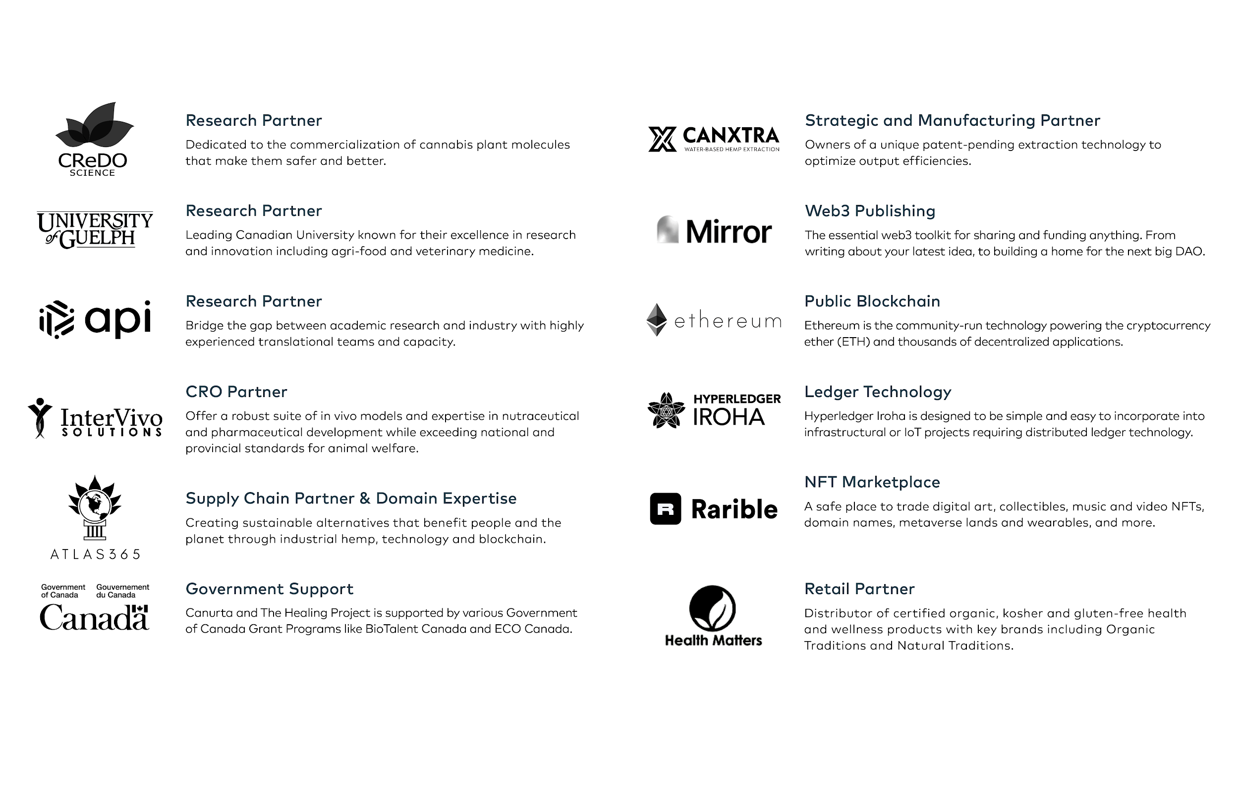

**Conclusion**

The Healing Project is an open and encouraging environment to innovate, share ideas and be rewarded no matter who you are. Our Token Holders will gain access to the DeSci Movement and join a community solving barriers to funding, research and transparent decision-making in the world of scientific discovery and health innovation.

The Healing Project community’s contributions will be recorded indefinitely on Canurta’s blockchain infrastructure, creating a truly collaborative approach to maximizing research applications towards natural solutions to fight inflammation and chronic disease, with a direct pathway to product development with transparent supply chain scale-up.

As such, Canurta remains fully accountable to a global, forward-thinking community, allowing for credibility and an ongoing culture of incentivizing the most important end-goals to promote longevity and a better quality of life for humans and animals alike.

**Footnotes**

1. ​​https://www.ncbi.nlm.nih.gov/books/NBK493173/
2. See NFT Roadmap for Scientific Outcomes.
3. Pricing will be converted to ETH at the point of auction.
4. Payable at year-end (Dec 31st) of Year 1 and semi-annually in Year 2 thereafter.

**Appendix 1: IP Summary**

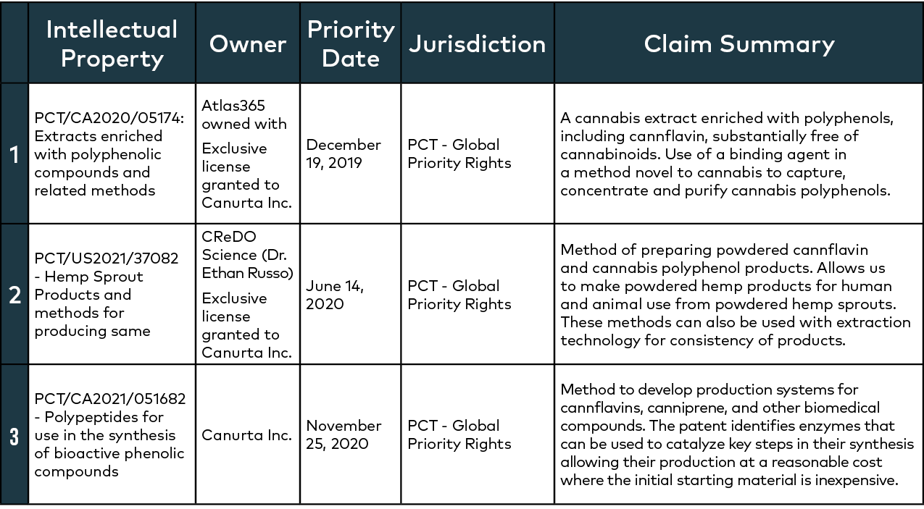

**Appendix 2: What are NFTs?**

Stored on a blockchain, NFTs are units of data that represent the ownership of unique artifacts or digital assets. Comparatively speaking, unlike fungible tokens such as bitcoin which can be traded or exchanged for other identical ones and have multiple owners, NFTs are one-of-a-kind. They allow us to tokenize items like artworks, collectibles and intellectual property rights and permit only one official owner at a time which is verifiable by Ethereum’s public blockchain.

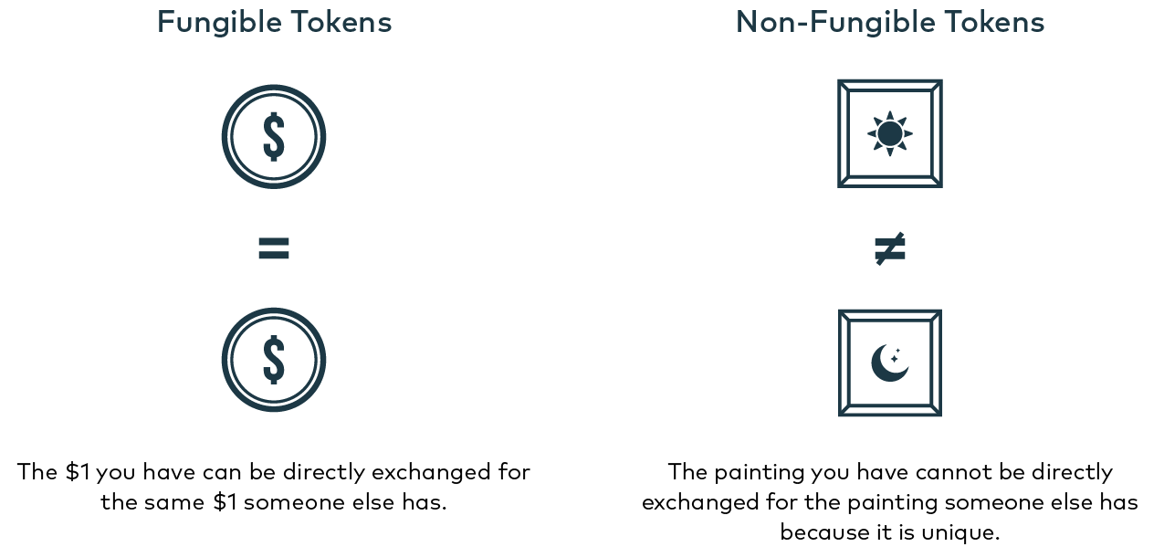

**Appendix 3: Blockchain for Canurta Supply Chain - The Basics**

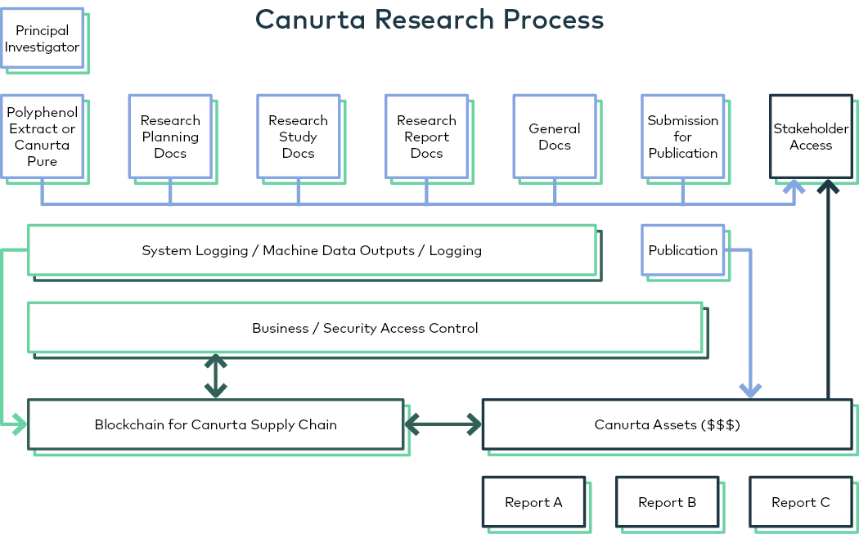

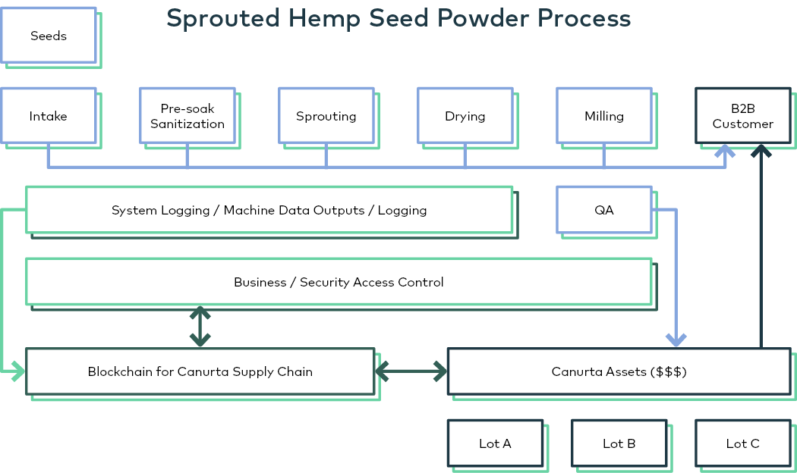

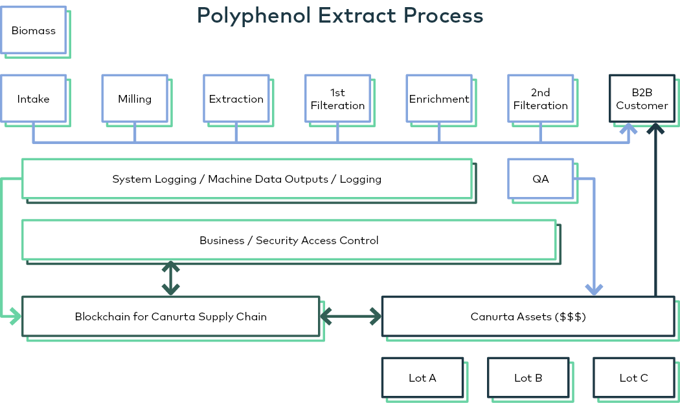

**Appendix 4: Canurta Team**

**Akeem Gardner, Founder & Chief Executive Officer** - Akeem Gardner brings a unique creativity and passion in creating the Canurta vision. Akeem is a true entrepreneurial thinker that uses his keen legal intelligence, through obtaining his L.L.B. from the University of Canterbury, to solve complex problems. As an innovative community builder in niche markets, Akeem recognized the unlimited downstream potential hemp-based products. He has spent the last four years catalyzing himself as a leader in the cannabis/ hemp industry.

**Pamela Kisun, Chief Operating Officer** - Pamela Kisun oversees the company’s day-to-day administrative and operational functions and ensures strategic alignment to long-term business objectives. She liaises with internal and external stakeholders and advises on corporate matters, including environmental, social and governance principles. Pamela completed her Master’s Degree in Climate Change at the University of Waterloo with a focus on mitigation and adaptation measures. She has several years of experience in various positions, including research and analysis, policy advising, project management and administration.

**Shega Youngson, Chief Brand Officer** - Shega Youngson leads the company’s brand development and is responsible for overseeing the planning, development and execution of our company's marketing and advertising initiatives including The Healing Project. Shega completed her Bachelor of Science (Hons) degree in Public Policy, Media and Graphic Communications at Rochester Institute of Technology. She is a leader in advocacy marketing, consumer engagement and brand strategy, with over 7 years of experience building marketing trends and launching new product experiences for leading cannabis brands and services, including Canopy Growth Corporation.

**Cameron Parry, Production Quality Assurance Manager** - Cameron Parry uses his knowledge and expertise to oversee the production of reliable products that consistently meet our standards and leads extraction optimization, purification and ingredient analysis. Cameron completed his Master’s Degree in Biotechnology at the University of Guelph and trained in metabolite extraction and analysis.

**Ricardo Hewitt, Chief Technology Officer** - Ricardo has been a pivotal asset in the development of Canurtas blockchain technology and NFT project. Ricardo obtained his Bachelor of Science (Hons) degree in Computer Science from Ryerson University. He has over nine years of experience in software development with relevant positions, including B.S.A. at 4Pay and F.E.D. at Rogers Telecommunications. Having completed I.B.M. Blockchain Essential and I.B.M. Blockchain Foundation Developer courses, Ricardo has been essential in architecting, designing, and coding version 1.0 of Canurta’s supply chain solution utilizing hyperledger fabric and I.B.M.'s resources.

**Dominic Poku-Aidoo, Chief Information Officer** - Dominic Poku-Aidoo assists in making all executive decisions regarding the technological interests of Canurta. Dominic obtained his Bachelor of Science (Hons) degree in Computer Science from Ryerson University and has 8+ years of experience in various aspects of software programming, including work as a Digital Developer at Rogers Telecommunications. He is a strong proponent of blockchain technology for impact magnification. He has been working diligently with Canurta to analyze code and software for proper integration of blockchain technology within the company’s operations; he has completed both the I.B.M. Blockchain Essentials and I.B.M. Blockchain Foundation Developer courses.

**Kelly Boddington, Research Associate** - Kelly Boddington provides scientific and technical expertise on research and development of a scalable platform for the synthesis of hemp-derived polyphenols. Kelly obtained her Ph.D. Biochemistry and Bachelor of Science with a concentration in Molecular Biology and Genetics from the University of Guelph, provisioning expert insight into developing the company’s biosynthesis platform. She has published several articles highlighting her areas of expertise including the “Characterization of the Synthesis Pathway of Bioactive Compounds in Cannabis Sativa for the Biosynthetic Production of Novel Pharmaceuticals” which is directly related to her work with the company.

**Eric Soubeyrand, Research Associate** - Eric Soubeyrand provides scientific and technical expertise on research and development of a scalable platform for the synthesis of hemp-derived polyphenols. Eric is currently a Postdoctoral Research Associate at the University of Guelph’s Molecular and Cellular Biology Department having completed his M.Sc. in Plant Biology and Biotechnology and Ph.D. in Plant Biology from the University of Bordeaux (France). His skill set includes biochemistry, genetics and molecular biology, transcriptomics, cell biology and plant physiology and bio-imaging. His current research involves the quantification and identification of various metabolites found in Cannabis Sativa and molecular genetics, protein purification and metabolic chemistry to study and synthesize these molecules on behalf of the company.